***User guide***

*Program overview*

This is simple text editor. Read .txt and .xml files. Program operates on desktop devices with Windows and Linux operating systems.

*User Access Levels*

Open source program.

*GETTING STARTED*

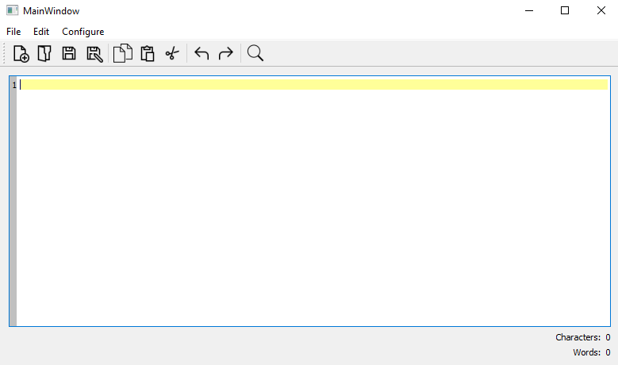

2

1

*Figure 1. Start page*

1 – tool bar: in accordance “New file(txt)”, “Open”, “Save”, “Save as..”, “Copy”, “Paste”, “Cut”, “Undo”, “Redo”, “Find”.

2 – counters.

You can hide/show line numbers in main tool bar in “Configure” tab.

To find text press Ctrl + ‘F’ or “Configure” -> “Find”.

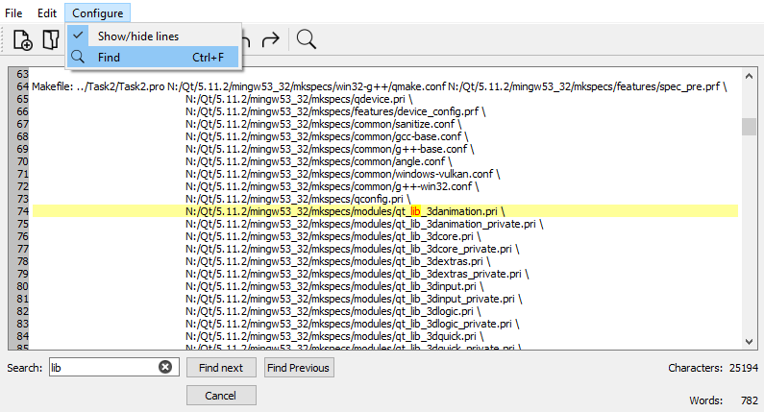

*Figure 2. Find text*

Then click “Find next” or “Find Previous”. Click “Cancel” to close search.

*Feedback*

Author Petruniak V.Y. Lviv. Ukraine. 2019.

e-mail: y.petrunyak@gmail.com